CSC443 Assignment 1

*I experiment writing and reading a 50 MB file consists of random characters.*

*And used 10 different block size ranging from 100b to 3MB to test the writing speed. And I did 5 tests for each block size*

*Block size:*

*100B 512B 1KB 4KB 64KB*

*256KB 512KB 1MB 2MB 3MB*

*type “make” in console to make executable :* create_random_file get_histogram

*And type “python3 write_random_file.py” in console to see the write rate printed out for all block sizes*

*type “python3 read_random_file.py” in console to see the read rate printed out for all block sizes*

***1 Writing rate experiment***

* 1. ***writing to mac pro SSDs***

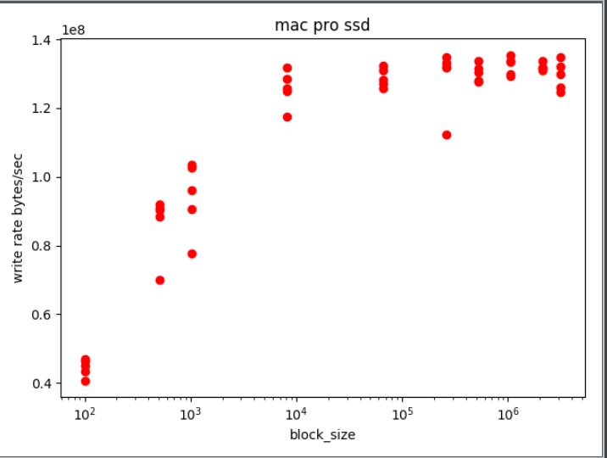

***Observation:***

*The writing rate keeps increasing until block size reaches 4KB.*

*The peak writing rate is about 130MB/second after 4KB block size.*

*The reason is that if the block size is smaller than SSDs page size, then it is inefficient since the same page has to be loaded into memory multiple times. So the optimum block size would probably be the page size of the SSDs which is 4KB in this case.*

* 1. ***writing to my desktop hard disk drive***

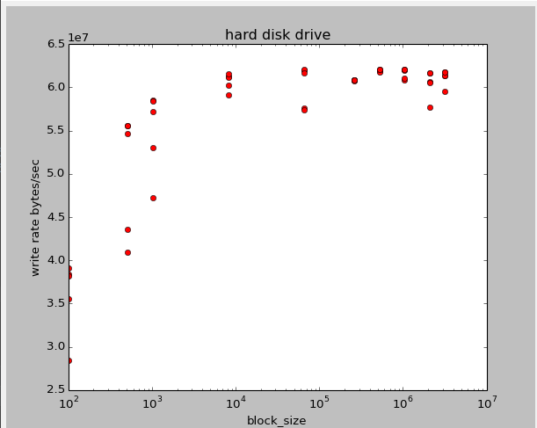

***Observation:***

*The writing rate keeps increasing until block size reaches about 256KB. The peak writing rate is about 62MB/second. we see that longer sequence of bytes tend to have more stable and better behavior since short writes might require more seeks and rotations for the hard disk drive.*

***Compare:***

Writing rate is low for both SSDs and Hard disk drives when block size is very small

But SSDs writes faster than hard disk drives.

And the optimum block size for SSDs is smaller than that for hard disk drives.

***2 Reading rate experiment***

*2.1 reading from mac pro SSDs*

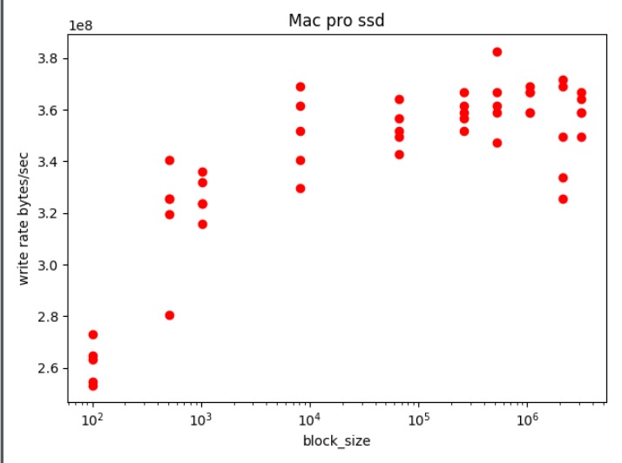

***Observation:***

*The writing rate keeps increasing until block size reaches 4KB.*

*The average peak writing rate is about 360MB/second after 4KB block size.*

*The reason is that if the block size is smaller than SSDs page size, then it is inefficient since the same page has to be loaded into memory multiple times. So the optimum block size would probably be the page size of the SSDs which is 4KB in this case.*

*2.2 reading from my desktop hard disk drive*

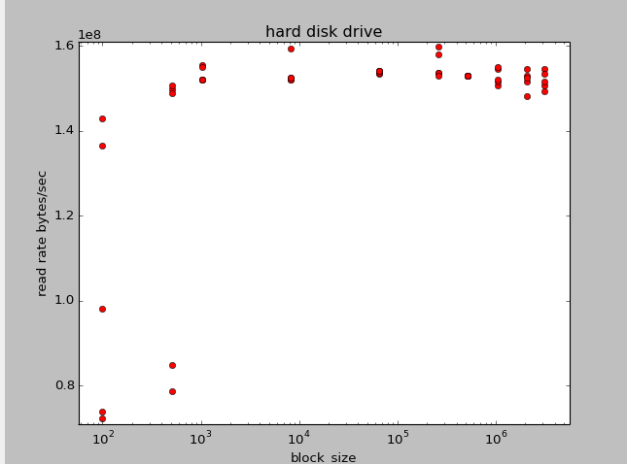

***Observation:***

*The writing rate keeps increasing until block size reaches about 256KB. The peak writing rate is about 150MB/second. we see that longer sequence of bytes tend to have more stable and better behavior since short reads might require more seeks and rotations for the hard disk drive. The optimum block size could be large as 256KB*

***Compare:***

Reading rate is low for both SSDs and Hard disk drives when block size is small

But SSDs reads faster than hard disk drives.

And the optimum block size for SSDs is smaller than that for hard disk drives.